Url Slug Suggestion - https://rootcabs.com/services/acting-driver
Primary Keyword

hire driver
acting driver
Secondary Keyword

acting driver near me
driver hire for outstation
book driver for outstation
personal drivers for hire
acting driver for outstation trip
acting car driver
acting driver charges
acting driver charges for outstation trip
acting driver service
car acting driver
car driver for outstation
car rental outstation with driver
driver on hire outstation
get driver for outstation trip
outstation driver hire
Page Layout

H1 - Acting Driver



H2 - What Is an Acting Driver?
H2 - Benefits of the Acting Driver
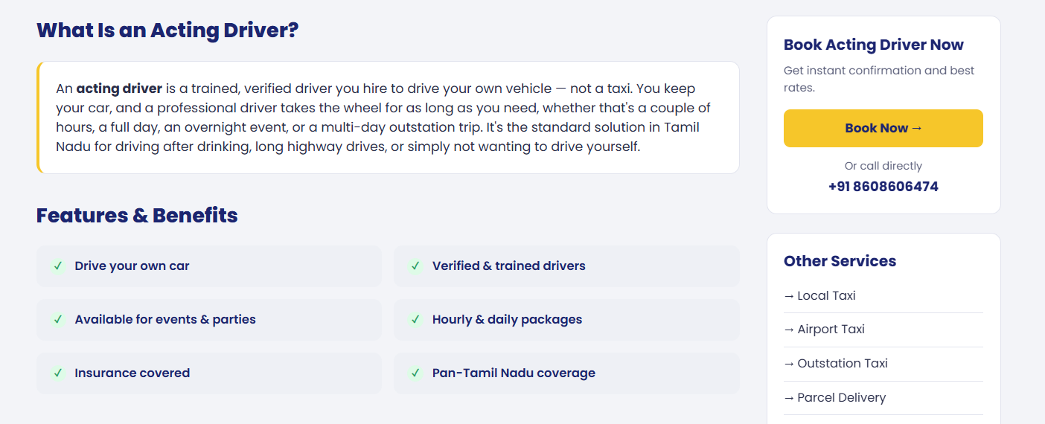

H2 - Why Choose Root Cabs for Acting Driver
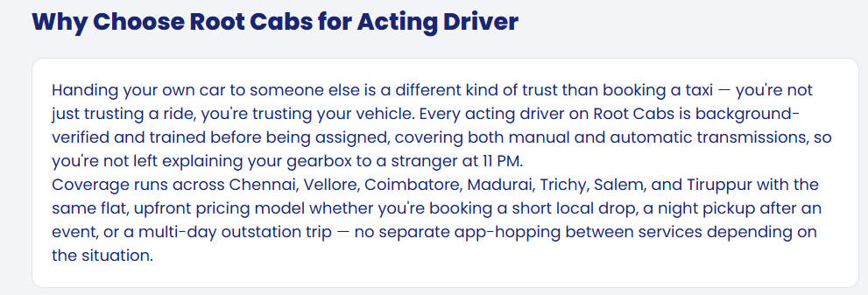

H2 - When to Book an Acting Driver
H3 - After Drinking
H3 - Outstation Trips
H3 - Events & Parties
H3 - Business Travel
H3 - Night Duty
H3 - Monthly / Regular Duty
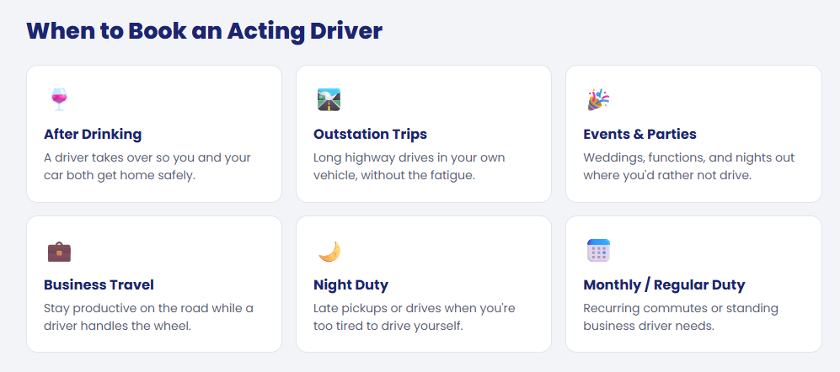

H2 -Acting Driver Charges
H2 - Acting Driver Payment Method
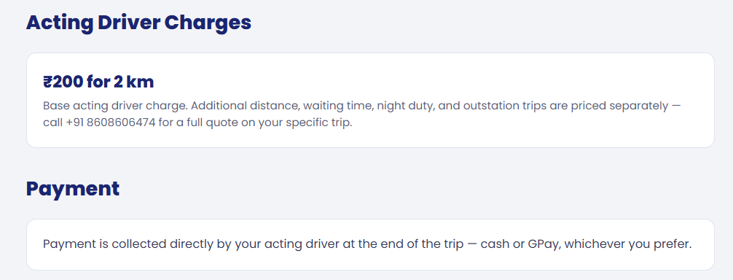

H2 - Acting Driver Available In

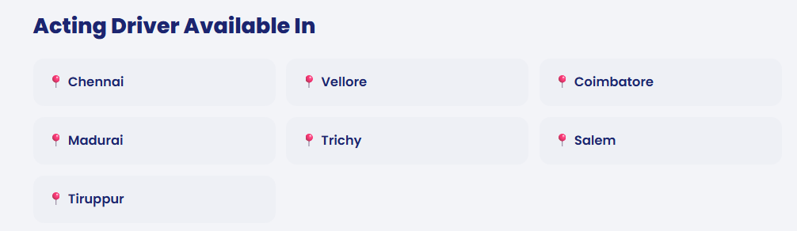

H2 -

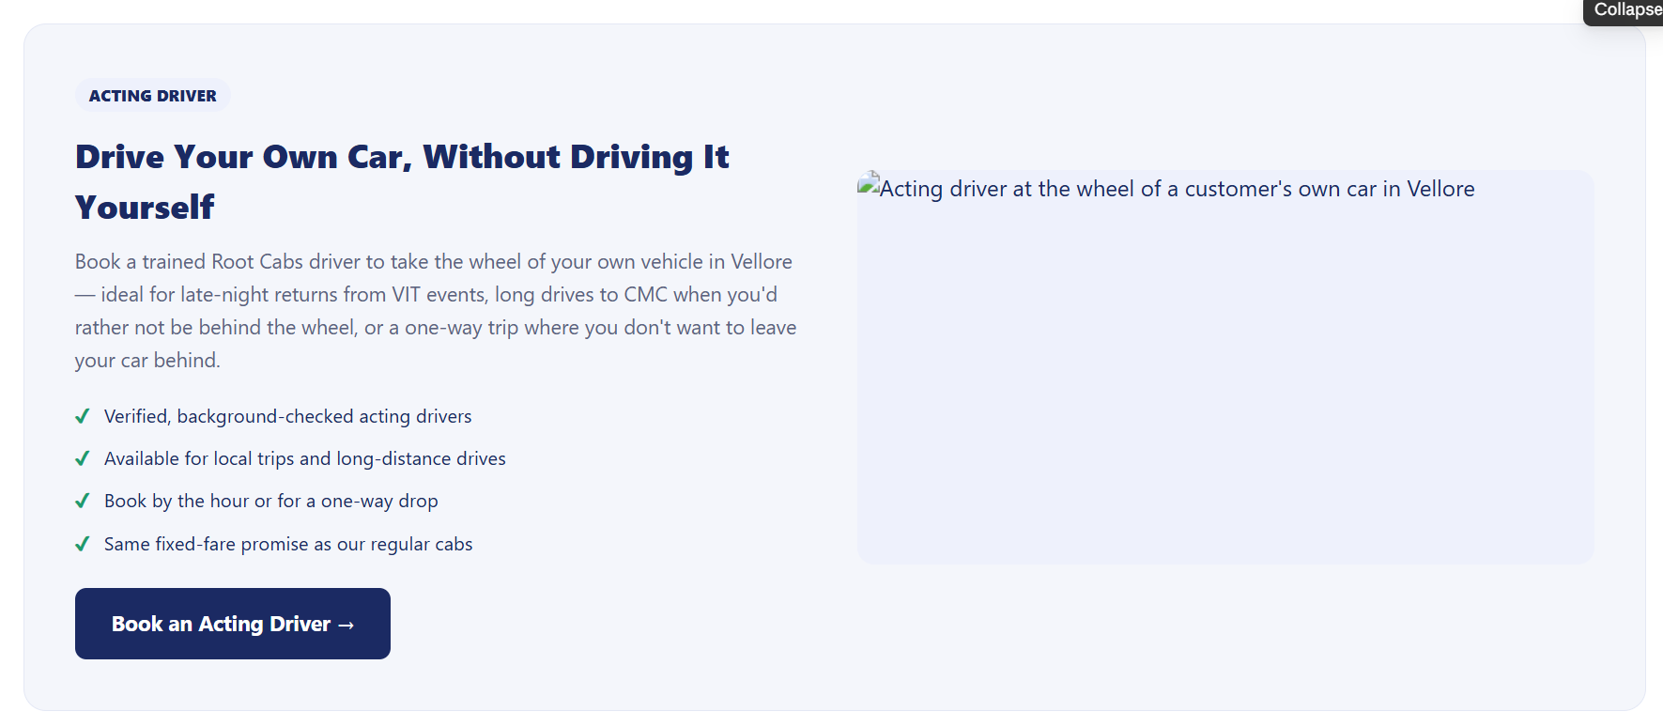

Acting driver section added - Purpose interlinking to the acting driver page.
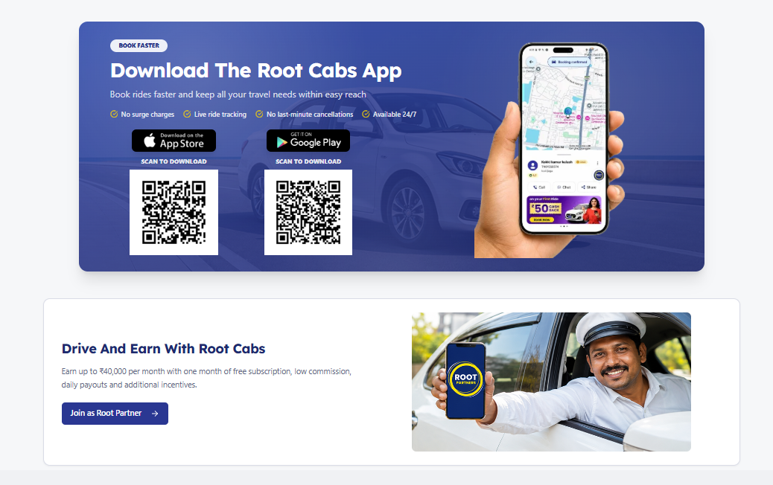

H2 - Frequently Asked Questions
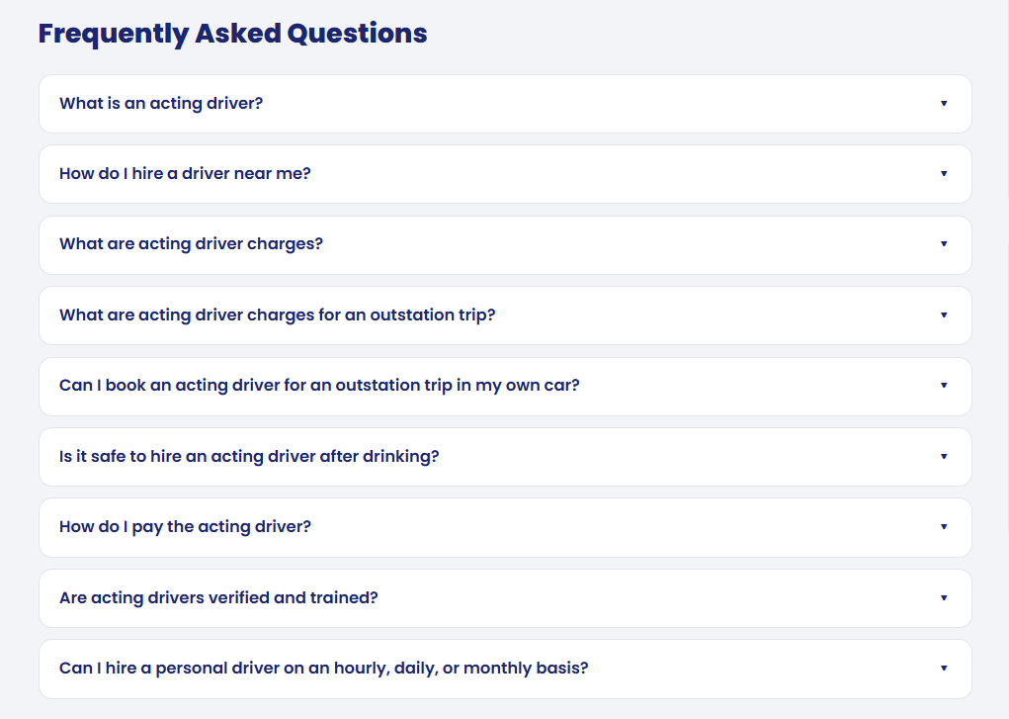
What is the salary of an acting driver in Tamil Nadu?
How to become an acting driver in Root Cabs?
What are the charges for an acting driver in Chennai?
How do I hire a acting driver near me?
Can I book an acting driver for an outstation trip in my own car?

